**CS506 Team 1 Deliverable 1**

**Team 1 - Spark! Project Team | Universal Basic Income - City Councilor Lara**

Questions to be answered:

1. How many people participate in assistance programs?
2. What is the income distribution for Boston residents living below the poverty line?

Question 1: How many people participate in assistance programs?

Answer :

Initially, we scouted for datasets that give the demographic understanding of the participants. Based on the data found and the filtering process, we have decided to focus on 3 Assistance Program

1, Supplemental Nutrition Assistance Program (SNAP)

2, Transitional Aid to Families with Dependent Children (TAFDC)

3, Emergency Aid to the Elderly, Disabled, and Children (EAEDC)

The below pie charts summarize the 3 programs together for the month of DEC 2022

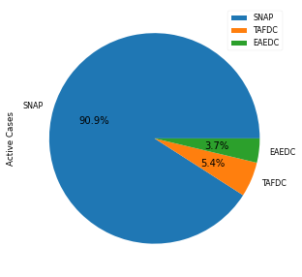

Image1: Active cases in Boston

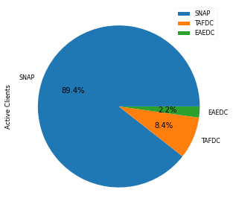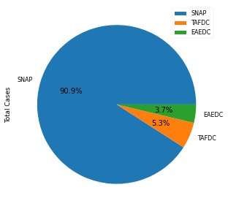

Image2 : Active clients in boston Image3 : Total Cases in Boston

Observation 1: SNAP Assistance seems to be the largest one compared to TAFDC and EAEDC. It is 9 times bigger than TAFDC and EAEDC combined. We have confirmed the same inputs from the client and the client would like to move forward with the analysis focus of the SNAP program.

***Analysis based on the geographical distribution of cases***

Geographical Heatmaps based on the number of active cases in Boston

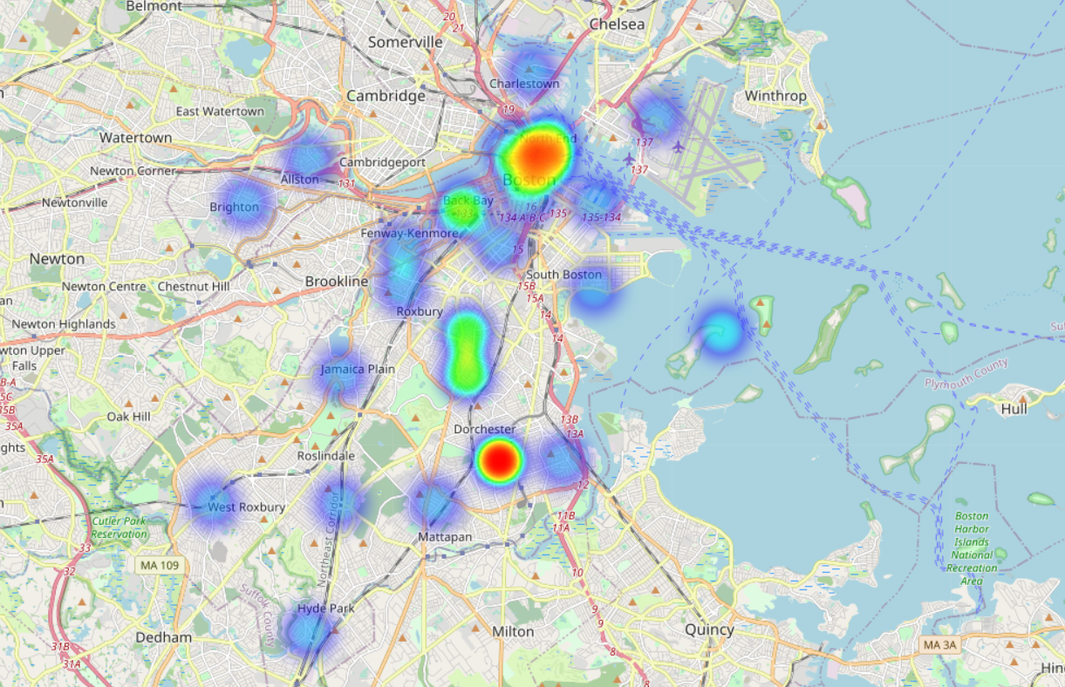

Image 4: Geographical heat map based on No. of active SNAP cases

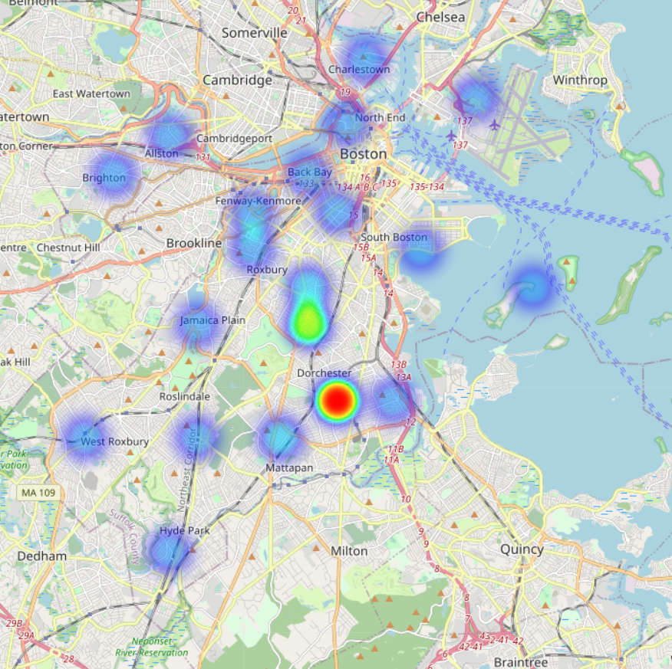

Image 5: Geographical heat map based of NO. of active TAFDC cases

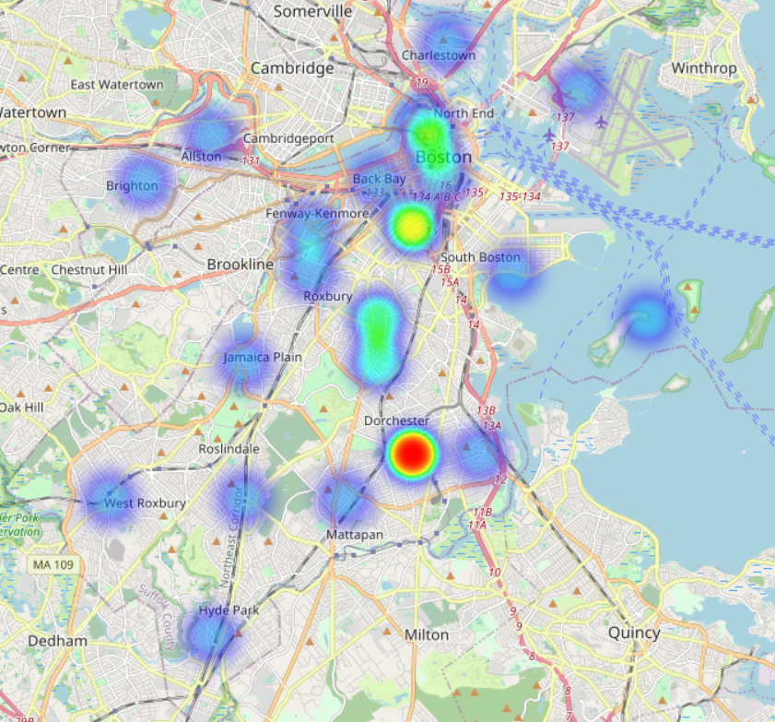

Image 6 : Geographical heat map based of no of active EAEDC cases

Observation 2: From the above Heatmap, we can conclude that a large number of residents of the Dorchester neighborhood receive assistance from these 3 programs. It is followed by residents of Roxbury residents

The same can be concluded from the below bar plots of the top 7 and bottom 7 places

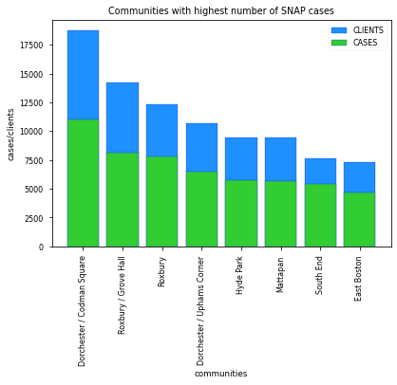

Image 7

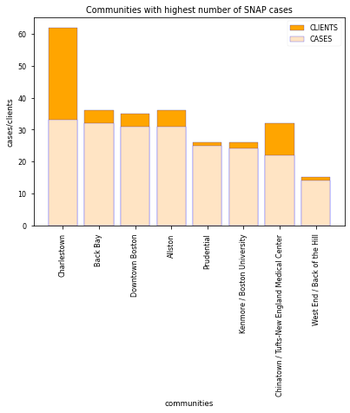

Image 8

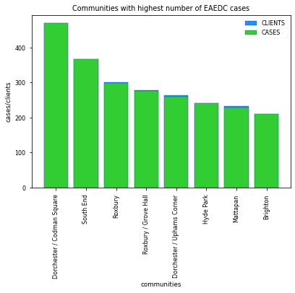

Image 9

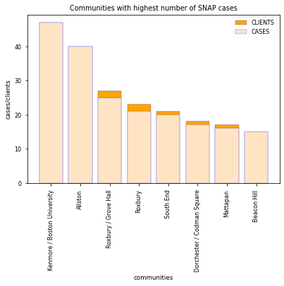

Image 10

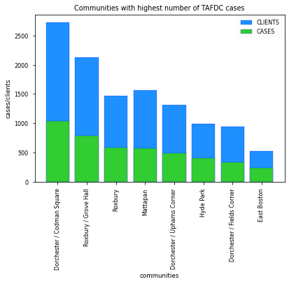

Image 11

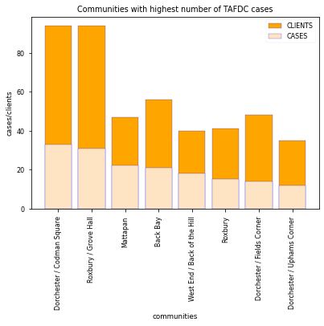

Image 12

**Demographical Analysis of SNAP recipients**

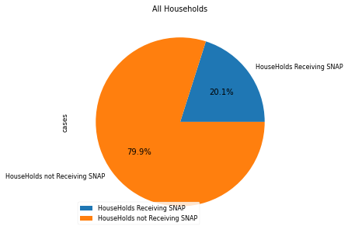

Observation: 1//5 of all households have received SNAP benefits

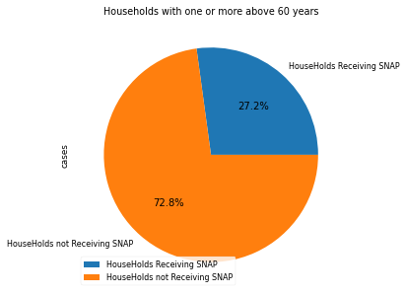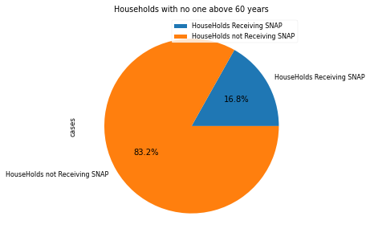

*Observation:* Households having people of age more than 60 received more SNAP benefits

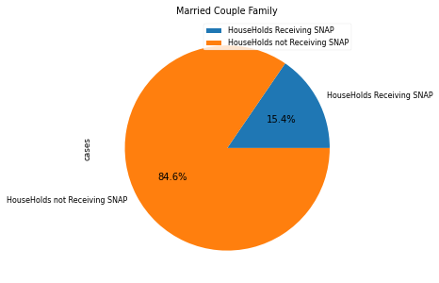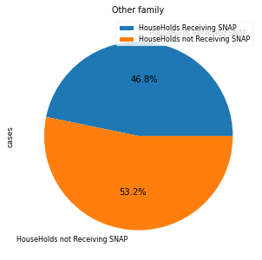

*Observation:* Households of Other family type has almost 50% of getting a SNAP assistantship compared to married households

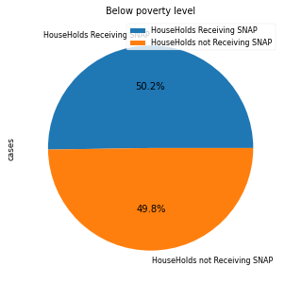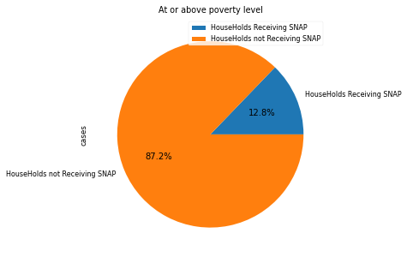

*Observation:* Half of the households under the poverty line got SNAP whereas only 12% of households above the poverty line got it

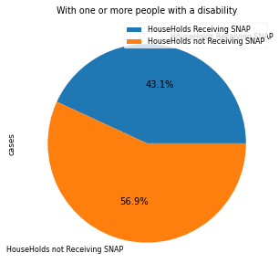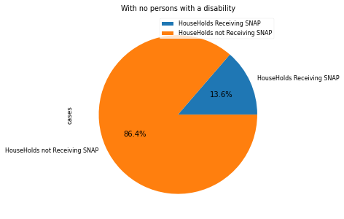

*Observation:* Half of the households with disability got SNAP whereas only 13% of households above the poverty line got it

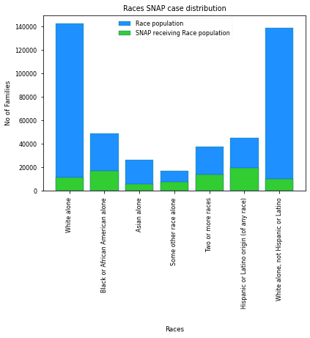

*Observation:* It can be observed that a large proportion of Black or African American and Hispanic races have got SNAP assistantships compared to other races.

Conclusions :

* Residents of the Dorchester neighborhood have enrolled maximum for the SNAP assistance program
* Factors that had an effect on the selection are :

1. community located
2. household with disability
3. poverty line,
4. Other family types

The datasets used are :

* <https://data.census.gov/table?q=SNAP&g=1600000US2507000>
  + 1. [Food Stamps/Supplemental Nutrition Assistance Program (SNAP) | American Community Survey | U.S. Census Bureau](https://www.census.gov/acs/www/about/why-we-ask-each-question/food-stamps/)
* [DTA Data and Research | Mass.gov](https://www.mass.gov/dta-data-and-research)
* [DTA_ZIPCODE_Report_DEC_2022.v2.xlsx](https://docs.google.com/spreadsheets/d/1EHLDQfJK_0Oxvz6Mi2mx_mdzFT9gmUuw/edit#gid=1234606162)
* <https://www.unitedstateszipcodes.org/02111/>

Question 2: What is the income distribution for Boston residents living below the poverty line?

Answer: We have gone through datasets available on poverty distribution for the population in Boston. And based on the data we were able to get from all the resources available we tried to answer this question. However, we are not successful in getting the exact income distribution related to the population over various categories. Based on the avg income range which indicates the poverty line and poverty distribution over various categories of the population we are trying to find out the income distribution of Boston residents. Below are a few bar plots that help in answering the question.

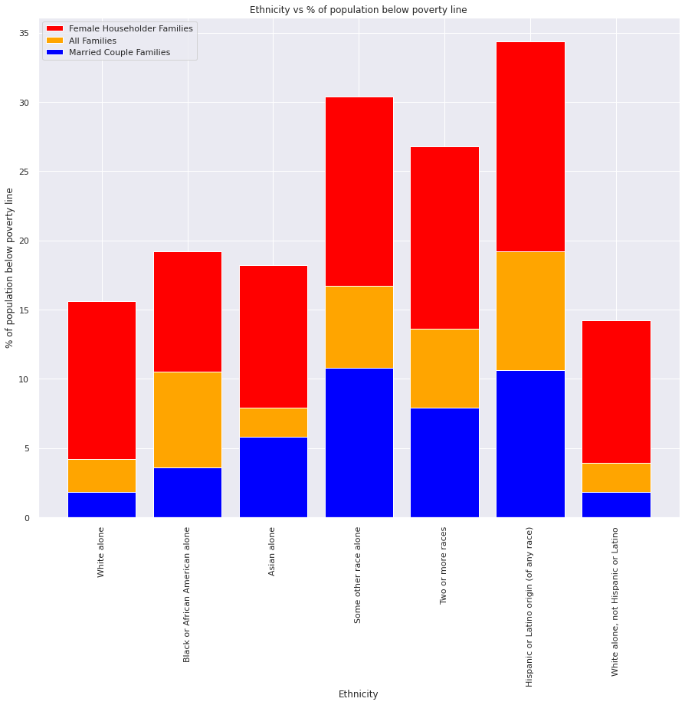

From the above plot, we get the distribution of people below the poverty line in each of the ethnic groups. And in each ethnicity, we have different categories of people and we can see the percentage of people below the poverty line is more in the case of families who have females as house householders in each ethnicity and less in the case of people who have married couples as householders. And overall we can see that people belong to Hispanic or Latino origin have the highest poverty population followed by Black or African household

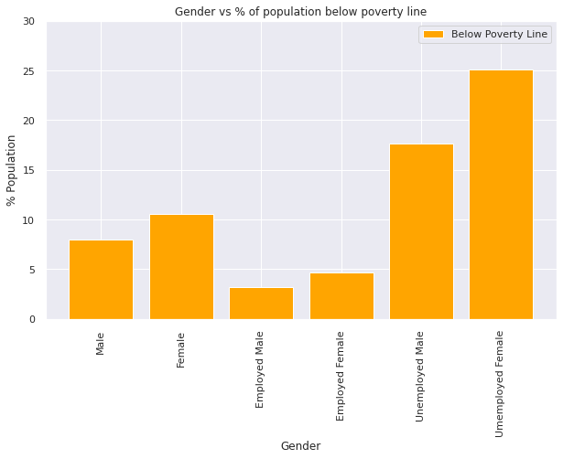

From the above plot, we can see the percentage of the population below poverty in relationship with gender. And also based on employment in each gender how the percentage of the population below the poverty line is varying. As expected the % of the population below the poverty line is high in the case of females who are unemployed.

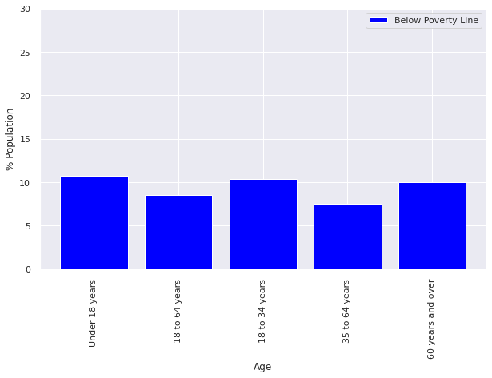

The above plot gives the distribution of the population in Boston which are under the poverty line in relation to age group

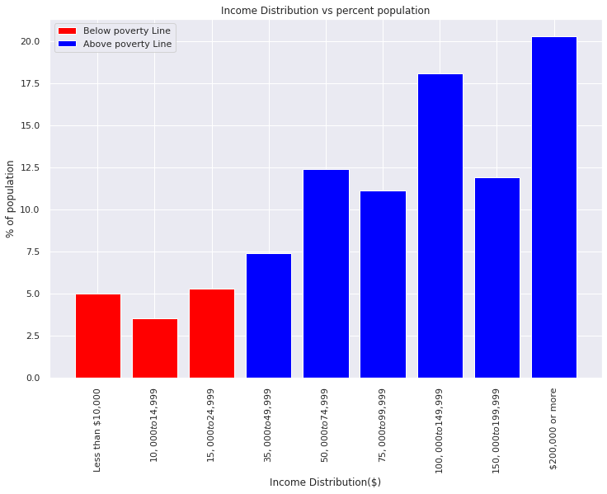

As from the following govt website '<https://aspe.hhs.gov/2021-poverty-guidelines'> the threshold income of a household of 4 people is '$ 26,500' and considering this we can say that the first three ranges in salary distribution(in red) indicate the percent population below the poverty line in the above plot

The datasets used are :

* Census income brackets/ poverty level: <https://data.census.gov/table?q=DP03>
* Income range: <https://www.huduser.gov/portal/datasets/il/il2022/select_Geography.odn>
* [https://data.census.gov/table?g=0400000US25_310XX00US14460&tid=ACSST1 Y2021.S1702](https://data.census.gov/table?g=0400000US25_310XX00US14460&tid=ACSST1Y2021.S1702)
* <https://data.census.gov/table?g=0400000US25_310XX00US14460&tid=ACSST1Y2021.S1702>
* <https://data.census.gov/table?g=310XX00US14460&tid=ACSST1Y2021.S1701>

Additional information:

Along with analyzing the data to answer the questions, we also tried to find the relationship between people who need aid/received aid and the total population within various geolocations.

We can see from the plot that SNAP support was given the most among the three aids, and the zip-code 02124, 02121, and 02119 have the most clients among all areas. This tells us that it is highly likely that these areas have more people that need to be helped than other districts, which means that we can tilt the supply to these areas more than the others.

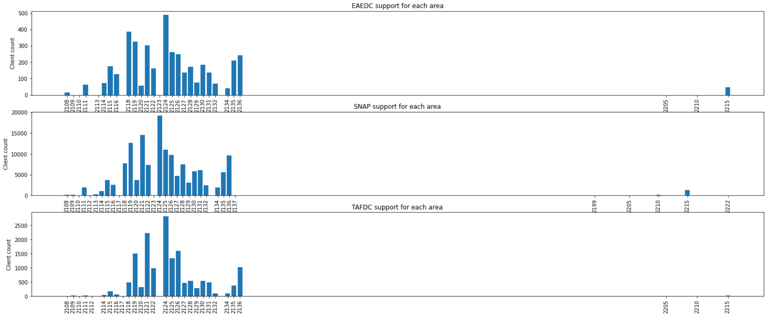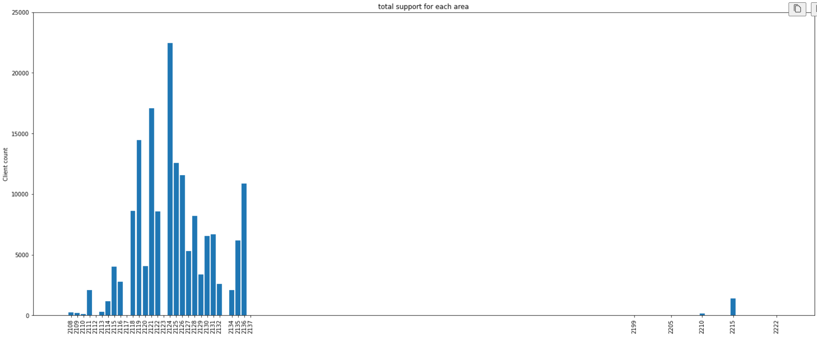

We also tried to use the population distribution data provided by Boston City Council for each district. There are some benefits and some limitations to this result.

Benefits:

- The benefit of this dataset is that we can clearly see the distribution and exact number of each race from each district (see figure below). From that information, combined with the information we get from other datasets, such as the aid given to each zip code area, we are able to tell which group of people needs more help compared to others. Then we are able to filter out where and how much aid in the future we will provide to each district/community/group of people.

Drawbacks:

- the Drawback we have is that the districts need to be identically drawn with zip codes. This means the boundaries between the two are not exactly the same, and we need to map zip codes to the appropriate districts for the benefits of this dataset to work. We do not yet know how vital this dataset is, spending effort on this task might not be a choice before we understand how vital this dataset is.

